1.Create a Node.js server to implement routes for /home, /about, and /contact that respond with

different messages for each route.

Node JS coding

**const express =require(express)**

**const app=express()**

**app.use(express.json())**

**app.get('/',(req,res)=>{**

**res.send(This is main page)**

**})**

**app.get('/home',(req,res)=>{**

**res.send(Iam from home page)**

**})**

**app.get('/about',(req,res)=>{**

**res.send(Iam computer science and engineering student)**

**})**

**app.get('/contact',(req,res)=>{**

**res.send('contact me on roogle.com')**

**})**

**app.get('/greet',(req,res)=>{**

**const name=req.query.name||guest**

**res.send(Hello, ${name}!);**

**})**

**port = process.env.PORT||3069**

**app.listen(port,()=>console.log(Port is running on ${port}))**

The main page after running the node js

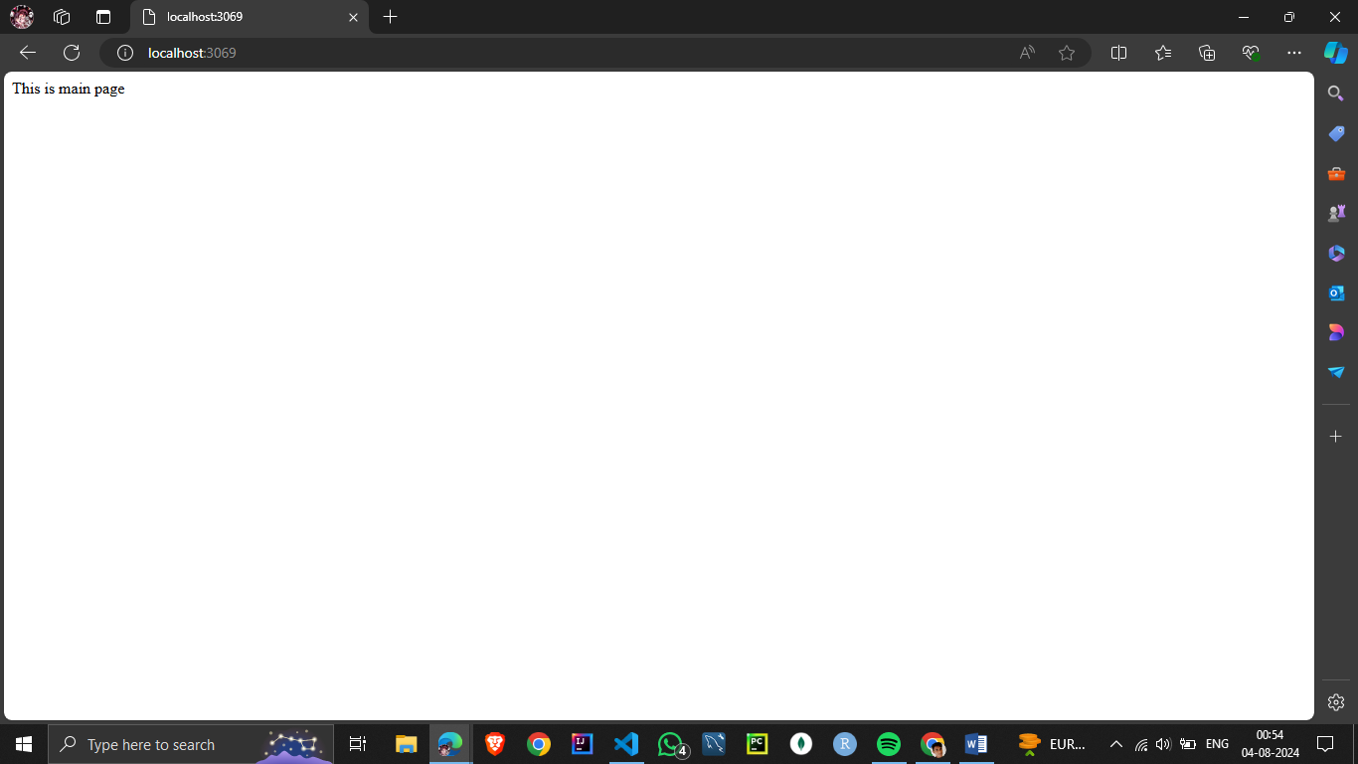

The home page

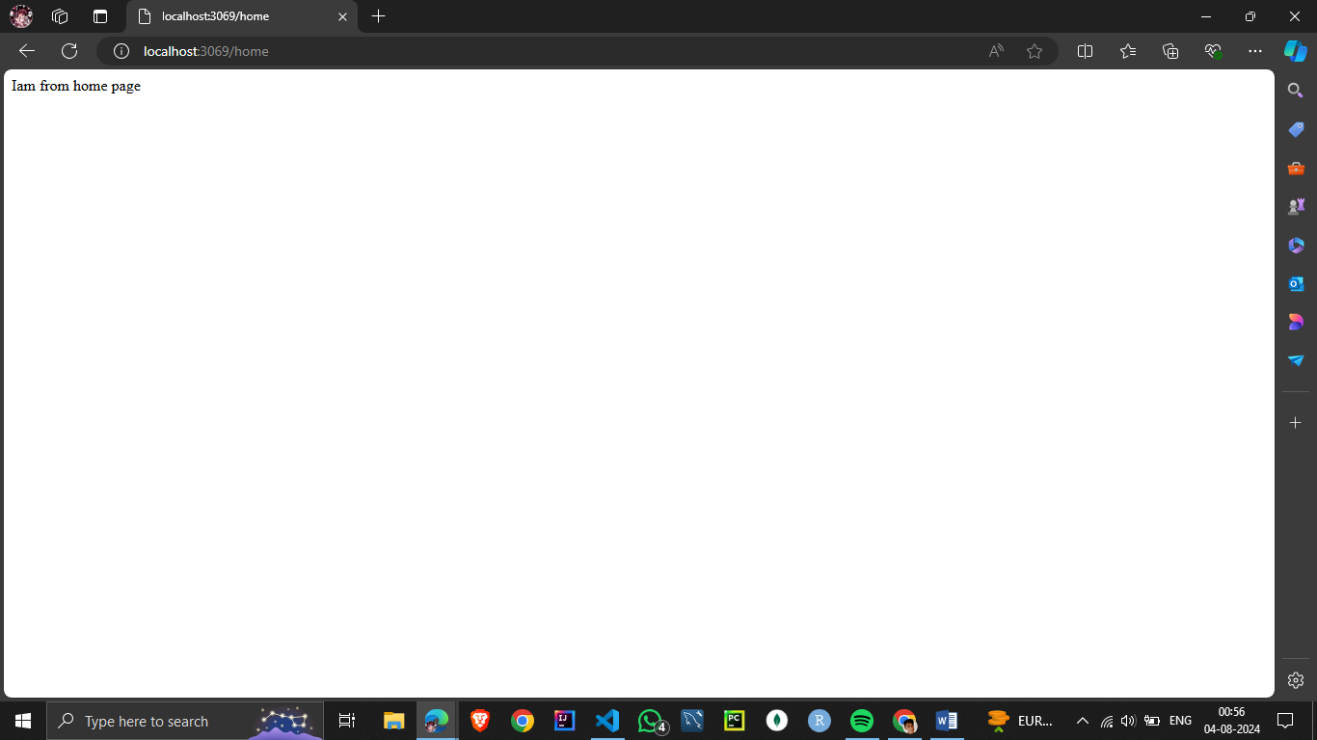

The about page

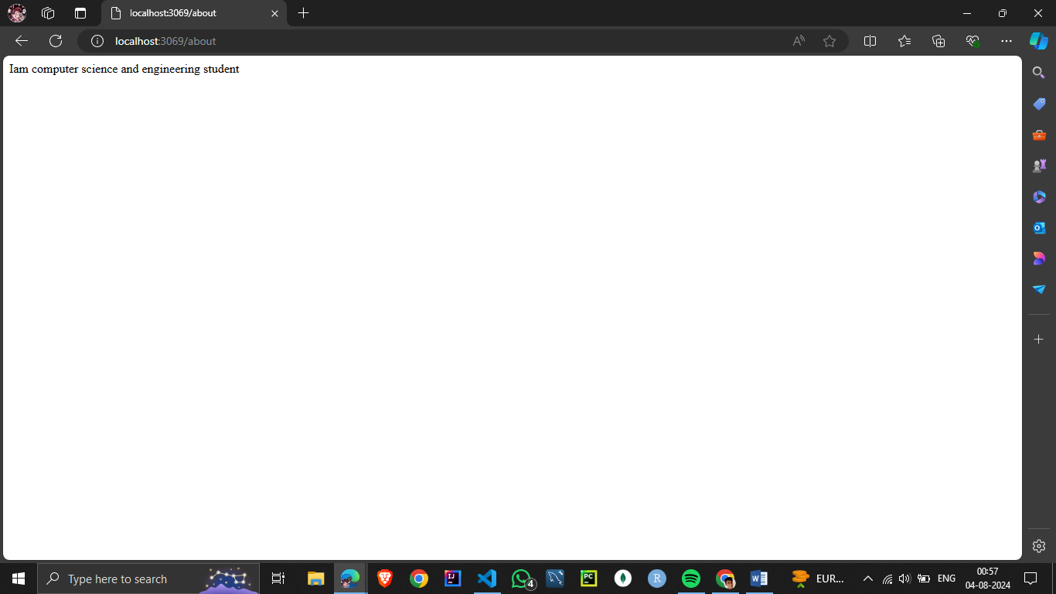

The contact page

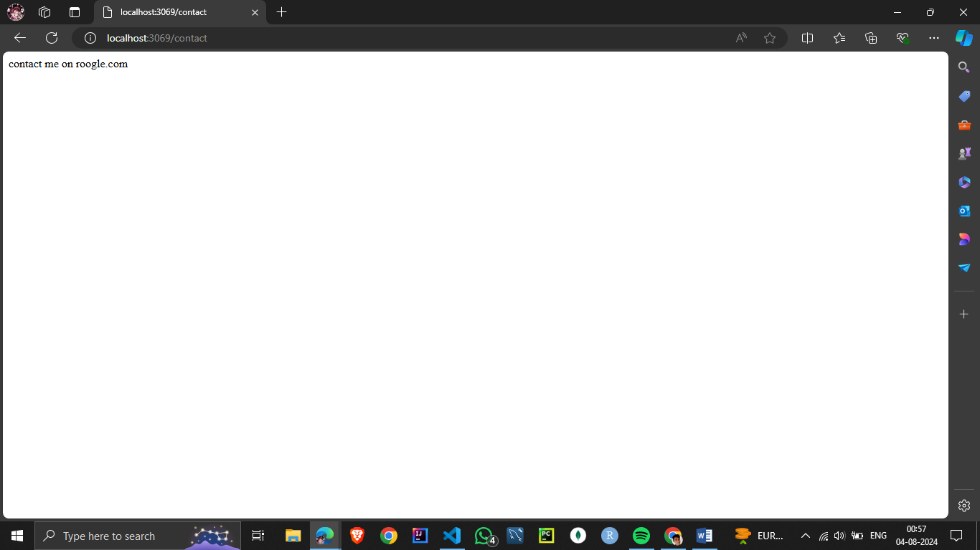

2.Build a server with a route /greet that accepts a query parameter name and responds with personalized greeting message, e.g., &quot;Hello, [name];

Node js coding:

**const express = require('express');**

**const app = express();**

**// Middleware to parse URL-encoded bodies (form data)**

**app.use(express.urlencoded({ extended: true }));**

**// Serve a simple form at the root route**

**app.get('/', (req, res) => {**

**res.send(`**

**<form action="/greet" method="POST">**

**<label for="name">Enter your name:</label>**

**<input type="text" id="name" name="name">**

**<button type="submit">Greet me!</button>**

**</form>**

**`);**

**});**

**// Handle form submission and greet the user**

**app.post('/greet', (req, res) => {**

**const name = req.body.name || 'Guest'; // Default to 'Guest' if no name is provided**

**res.send(Hello, ${name}!);**

**});**

**// Start the server**

**const PORT = 3000;**

**app.listen(PORT, () => {**

**console.log(Server is running on http://localhost:${PORT});**

**});**

